**POWER DISTRIBUTION CIRCUIT**

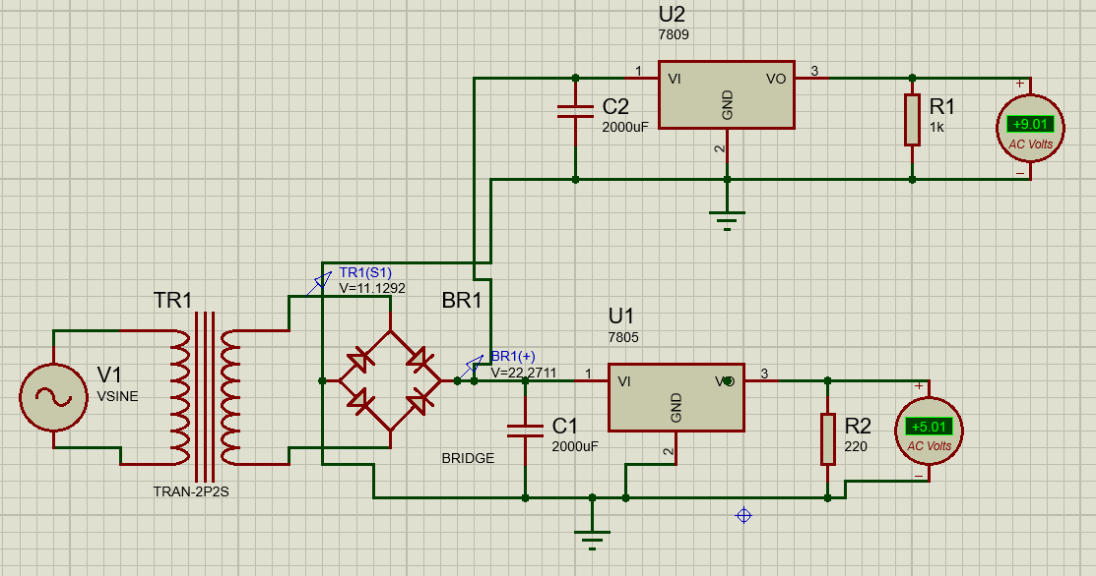

**ABOUT**

In the above circuit we aim to bring two DC voltages that is 5V,9V from a 220V AC supply.

**WORKING**

From the 220V AC supply we use the step down transformer to minimize the amplitude of the voltage supply. After that we use a full wave bridge rectifier to convert the AC to DC.

But we find that in the output of the rectifier, ripple factor is still there and hence to minimize it to the lowest level we use a capacitive filter. We use a large value of capacitor so as to minimize the ripple as much as possible. Then after getting a DC output we passed on the supply to a voltage regulator(7805,7812). The use of the voltage regulator is that it will give a constant voltage i.e 5V for 7805 and 12V for 7812 besides any variation of voltage in its input side. Hence across the 220ohm load we get the desired voltage.

**DEVICES USED**

**TRANSFORMER**

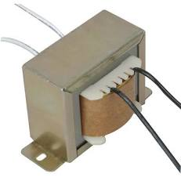

**VOLTAGE REGULATOR**

**7805**

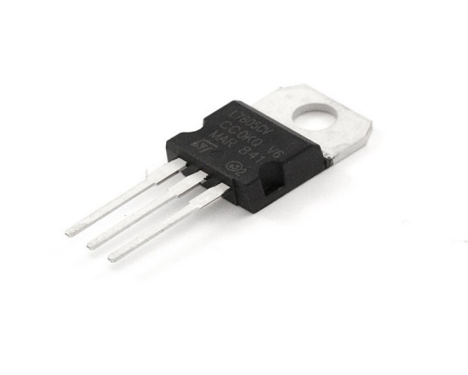

**7812**

